Annex 2
ITU Centres of Excellence Network for Asia-Pacific Region
Training on
" Quadplay: Costing and Pricing Infrastructure Access”
15-19 August 2016
AETAS lumpini , Bangkok,Thailand

INFORMATION NOTE

- Introduction

The ITU Asia-Pacific CoE Programme on “" Quadplay: Costing and Pricing Infrastructure Access” will be held from 15-19 August 2016 in Bangkok, Thailand

This training is organized jointly by the ITU, the National Broadcasting and Telecommunications Commission (NBTC) and the Ministry of ICT of Thailand as part of the Policy and Regulation Programme under the auspices of the ITU ASP COE. The training will be followed by a forum discussion on telecommunication/ICT economic and financial priorities in the Asia-Pacific region.
The training will be delivered in English.

- Venue of the Training
AETAS lumpini ,Bangkok,Thailand

- Coordinators
INSTITUTE COORDINATOR  Mrs. Sudaporn Vimolseth  TOT Academy  Nonthaburi,Thailand  Tel: +66 2 580 1076  Fax: +66 2 591 8087  E-mail:sudaporv@tot.co.th | ITU COORDINATOR  Mr. Ashish Narayan  ITU Regional Office for Asia Pacific  Bangkok, Thailand  Tel. +66 2 575 0055  Fax +66 2 575 3507  E-mail:ashish.narayan@itu.int

- ON-SITE REGISTRATION AND Working Hours
Venue AETAS lumpini ,Bangkok,Thailand
Date : 15 August2016 ;Time : 0800 AM Onwards

- Visa Formalities
All participants entering Thailand must possess valid passports or accepted travel documents and need to check visa requirements before entering the country. Please check the visa with the nearest Thai Embassy. For more information please visit the website http://www.mfa.go.th.

6. ACCOMMODATION
AETAS lumpini is a contemporary hotel in the Bangkok business district. Located opposite Lumpini Park, the hotel offers guests exquisitely decorated and furnished rooms supported by a staff and management dedicated to making your stay in Bangkok both productive and memorable. If you are visiting Bangkok for shopping, sightseeing or business purposes, you will be pleased to know that AETAS lumpini is conveniently located within easy walking distance of Sathorn, the business district of Bangkok, and is adjacent to the MRT Lumpini station, and close to the expressway. A trip to Suvarnabhumi airport from AETAS lumpini takes just 40 minutes.
Participants can book the proposed hotel through the organizer for special rate and confirm the availability or if preferred other hotel for their convenient. Please check the traffic to the training venue in the morning.Reservation form is attached at the end of this document.

- DETAILS OF ARRIVAL AND TRANSPORT
Participants are recommended to arrive at Suvarnabhumi International Airport, which is located 40 kilometres to AETAS lumpini Bangkok. More detailed information can be found on the following web site http://www.suvarnabhumiairport.com/.For your arrival at Suvarnabhumi International airport, airport taxis and public taxis can be easily found from point of entry to hotels. Airport taxis will cost more than public one. All participants are requested to make their own travel arrangements from airport to the hotel.
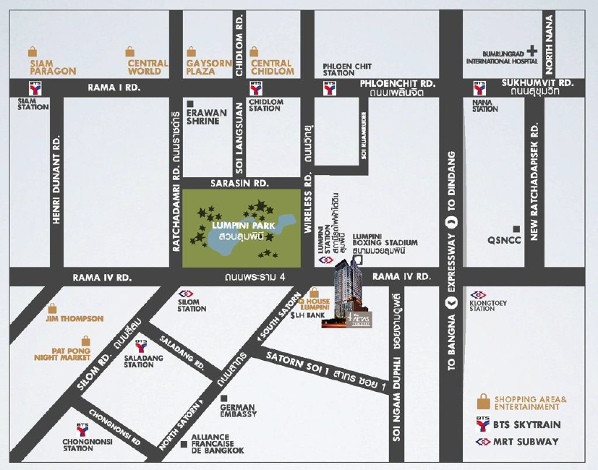
Map of AETAS

- CURRENCY
The currency exchange for Thai Baht to 1$ USD is currently approximately 33-35 baht. Government and business offices are open from 8.30 to 16:30 hrs, Monday to Friday. Bank opens Monday to Friday from 9.00-15.30 hrs while the department stores open daily from 10.00-20.00 hrs.
- ELECTRICAL APPLIANCES
The electric current is 220 volt AC throughout the country.The picture/diagram shows the type of main power plug used in Thailand so participants can bring the right adaptor for their electrical appliances. This plug and receptacle are technically known as NEMA 5-15 (North American 15 A/125 V grounded).
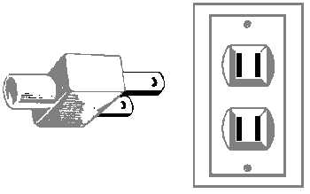
- LANGUAGES
English is spoken in most hotels, shops and restaurants as well as in major tourist destinations

- SECURITY
It is safe in Bangkok but however to travel at night time alone is sometimes not recommended.

- MEDICAL AND HEALTH
All participants are requested to ensure medical and travel insurance covering the whole period of the training course and overseas travel. Neither ITU nor the NBTC or MICT will be able to meet any expenses relating to injury, accident or medical treatment of the participant.
Drinking water from the tap is NOT recommended even though it is clean.

- WEATHER
The time in Bangkok is 7.00 ahead of Greenwich Mean Time (+7.00 GMT). In August, the temperature is between 28 -35 degree Centigrade.

- INTERNET
Complimentary wireless Internet access is available throughout the hotel and high-speed wired Internet access is available in all guest rooms.

Have a safe trip


ITU Centres of Excellence Network for Asia-Pacific Region

Quadplay: Costing and Pricing Infrastructure Access

15 – 19 August 2016

Thank you very much for choosing AETAS LUMPINI. Please fill up this reservation form with the following detail and email to : Reservation Lumpini Email : reservationgroup1@aetashotels.com
Cc : Ms. Punthiwa Punkong (Senior Sales Manager) Email : punthiwa_p@aetashotels.com

Title | First Name |  | Last Name |  |  | Confirmation no.
Company Name |  | '
Address
Telephone/ Fax
Email
Arrival date |  |  |  | Departure Date
Flight Detail |  |  |  | Flight Detail

Limousine Transfer: by Nissan Teana at THB 1,500.-net per car per way
□ No. Yes □ One way (Airport - Hotel) □ Roundtrip (Airport -Hotel-Airport)

Room rates:
Deluxe room : Single THB 2,209++ (THB 2,600.-net) / Double, Twin THB 2,464++ (THB 2,900.-net)
Junior Suite : Single THB 3,229++ (THB 3,800.-net) / Double, Twin THB 3,484++ (THB 4,100.-net)

Room type | Single | Twin | Double | Triple
Deluxe room
Junior Suite

*All rates are net exclusive tax and service charge
*Rates are inclusive for breakfast and in room internet access
*Extra Bed at THB 1,200++ (THB 1,412.40.-net) per room per night

Payment: □ Guest own account □ Other___________________

Guarantee Method: by Credit Card ______________________________________Expire_____________

Special request: □ Non Smoking room □ Smoking room □ other

Check in/out: Please be noted that our check in time is 14:00 hrs and check out time is 12:00 hrs. For early arrival and late check out is subject to room availability.

Cancellation Note: No charge until 72 hrs before arrival date. In case of late cancellation a charge equivalent to 1 night of the room rate and tax will apply.

Should there be any changes in the reservation details, please inform us as soon as possible to avoid “No-Show” charges.

Remark: Please reserve accommodation 2 weeks in advance of period check in due to high occupancy during that period.

(______________________)
Guest’s Signature
(dd/mm/yyyy)

